Julien P-H, Jordan A., Noah M., Brandon L.

Kindred
Game Design Document

Game Design Document

Executive summary:
Story: The player is lured into this world by a trick played by an unknown enemy, and he has to navigate through the world believing he is trying to save a friend or family member when in reality it was all a trap to capture him. At the end he must escape and fight this big enemy to escape the world.
World: Castle dungeon with goblins everywhere.
Characters: Main character is dropped into the world, he must defeat goblins to get a bow and a healing power. The final boss is a ruthless giant goblin with multiple phases.
Game mechanics: Kill enemies and bosses, after each kill collect some XP or points to use in the skill tree. Adapt to different weapons and mechanics as you progress through the game. Play with a certain number of hearts for added difficulty.
Beat the game: Fight against one final boss to complete the game. Kill every enemy to have enough XP to complete the skill tree (for 100% completion).

User interface mock-up:
Skill tree: 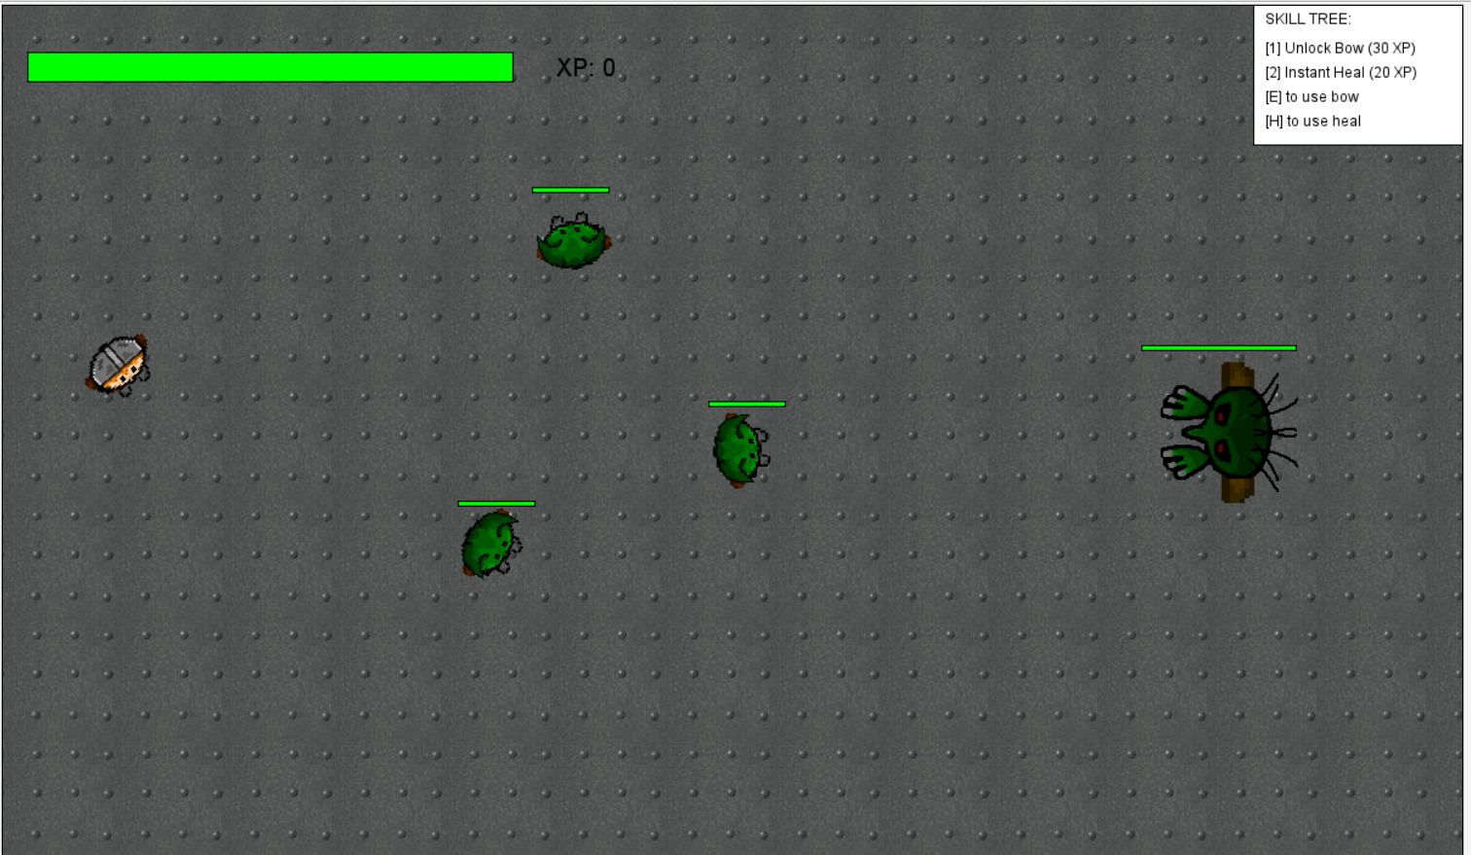

Player, enemies and boss (original):
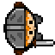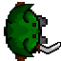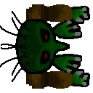
Heal Item (original):
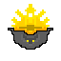
Flow between screens:
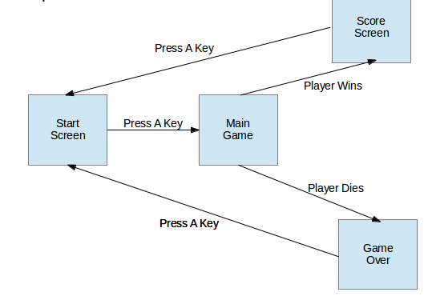
Level design: 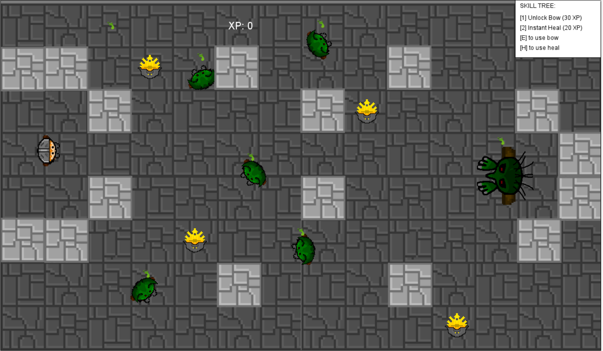

Game over screen:
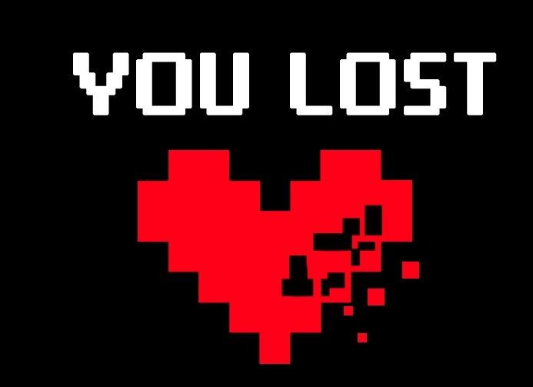
Game Win screen:
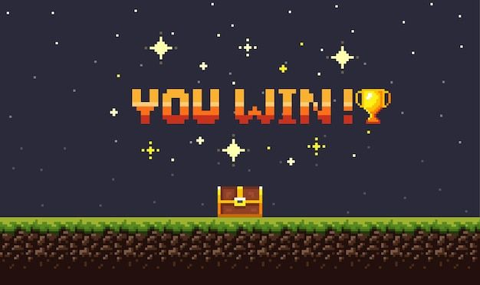

Game controls:
- Attack: space
- Movement: WASD
- Aim Character: Move mouse (mouse tracking).
- Skill tree: [1] for bow and arrow, [2] for heal power.
- Pause/Main menu: escape

Task and schedule breakdown:
Noah: Art creation, game world programming.
Jordan: World transitions and sound and audio programming.
Brandon: Images, sound and audio finding, GUI programming.
Julien: Entity programming, level layout design.
Deadline: December 4th.

